Name: Ningyuan Zhang

Section: A

Date: 2/15/2017

Instructor: Akhilesh Tyagi

Lab-4

Section A: SPIM

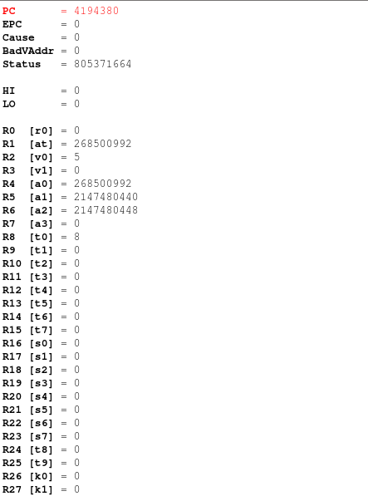

Section B: MIPS Assembly

a). All comments are added to the lab4b.s

b). The assembly file called procedure

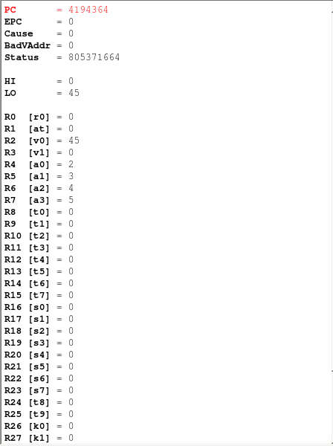

Section C: Machine Code

machine code of the procedure part:

